**HAFSA QURESHI**

**EL-19007**

**TELECOMMUNICATION NETWORKS**

**FINAL LAB TASK**

**Fire Detector**

Components:

1. Fire sprinklers
2. Monitor control MCU-PT
3. Fire monitor
4. Heating element

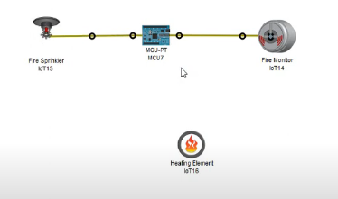

Create new project:

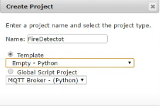

Programming for control unit:

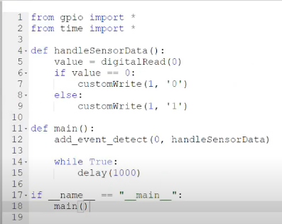

For heating element:

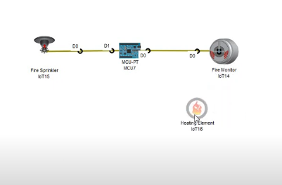

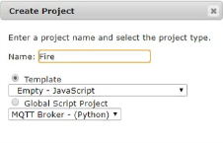

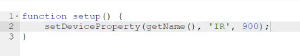

Move the fire near the Fire Monitor, the Fire Sprinkler will sprink the water to stamp out a fire. 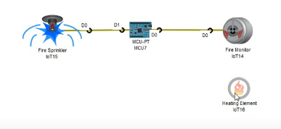

And when move the fire far away from the fire monitor, the sprinkler stop spraying water.

